For my proposal, I would like to investigate talker-specific model development. Specifically, if prosociality moderates speech perception adaptation when a listener is learning to understand an unfamiliar talker.

Humans tend to perceive the world through contrast, in both physiological and psychological contexts. Unlike how other sensory information is processed --including most audio stimuli-- a general schema for speech perception is developed during the critical period of childhood, and then constantly updated using information from interactions throughout their lifetime. This results in speech perception being a highly social-dependent process; even the initial schema that solidifies in early childhood is determined by what verbal cues the people around them use to differentiate meaning.

When a listener encounters a novel talker, they use their beliefs about talkers in general as a baseline assumption for how the novel talker will differentiate the sound cues they produce. Earlier research proposes that listeners maintain this baseline assumption as a general model that is updated throughout every interaction, while also learning an individualized model to each specific talker to communicate efficiently with that specific individual. The development of a talker specific model is what allowed us to observe an effect in our previous experiments when we introduced participants to a simulated unfamiliar talker.

In our previous experiment, we took additional measures to improve the ecological validity of conclusions drawn from earlier research in the field. One factor we accounted for was that the typical native English talker’s production of /d/ varies less than their production of /t/. We attempted to mimic unequal variance throughout exposure to our simulated talker by randomly drawing stimuli from the VOT continuum that would produce density curves reassembling those created using information from a production database.

The participants were exposed to these stimuli so that VOTs closer to the mean VOT production for /d/ and /t/ appeared more often. Because /t/ varied more than /d/, the density around the mean /d/ VOT was higher than the density around the mean /t/ VOT. As a result, where the /d/ and /t/ distributions overlapped were closer to the mean /d/ sound than if equal variances had been used for both categories. In theory, this would have then shifted the expected PSE to the left when simulating unequal variances.

I am curious if the average participant would produce different PSE values when the /d/-/t/ distribution is shifted depending on if unequal or equal variances are simulated during exposure. It has been very difficult for me to explain this question: When a listener is exposed to an unfamiliar talker whose distribution of cues is shifted together as a unit along the cue continuum, would the listener project the expected variances on to the talker specific model if the categorical means are signaled to be the same distance apart from each other? Or, alternatively, would the competition emerging where the general model and the talker specific model overlap outweigh the importance of the variance in the general model? I made up some annotated graphs included on the last page to try to show the differences I am interested in that is caused by the variance.

If the average PSE values differ significantly, then individuals may not be attempting to map the variances from the general model to the talker-specific model. To examine this, we could have 3 conditions: the control (typical /d/-/t/ production distributions), a 20-40* millisecond shift condition of that distribution, and finally that same shifted condition, but presented with equal variances. The mean VOT values for /d/-/t/ should be labeled trials in all conditions to facilitate participants targeting where the /d/-/t/ distributions should be centered.

*A value within this range should work: <20 msec may be too little category overlap; >40 cannot be done with our stimuli

Additionally, I would like to add a short survey to the beginning of the experiment. This would include 4 questions from the [Prosocial Behavior Intentions Scale](https://www-tandfonline-com.ezp.lib.rochester.edu/doi/pdf/10.1080/00223891.2017.1411918) (PBIS). The responses are presented in the form of 7-point Likert scales (See *Appendix* on p. 111) that measure an individual’s disposition towards helping others. I would also like to include the [BIS/BAS Scale](https://www-proquest-com.ezp.lib.rochester.edu/docview/614331851?accountid=13567&parentSessionId=7eGoeOw2WwCIu5PFDA9f4ftJigiQSO8fySA8EElNvj0%3D&pq-origsite=primo), which is composed of [24 questions rated on 4-point Likert scale](https://scienceofbehaviorchange.org/measures/bisbas-scale/)s. The BIS/BAS Scale was created based on Gray’s theory of personality, and is focused on the Behavioral Inhibition System (BIS) and the Behavioral Approach System (BAS). It is used to gauge a disposition to anxiety and impulsivity, and recent evidence has emerged that suggests these measures are correlated with neurological function. I feel that this information is valuable for future projects and may contain interesting trends.

*There is a second factor I would also like to introduce, though I recognize that these may be two separable projects. However, I will explain later why I think it would be beneficial to explore both factors simultaneously.*

If possible --and I know this could complicate the analysis and may present a problem with the quantity of participants-- I would also like to test if prosocial cues influence speech perception adaptation. Returning to the social element of speech that I find so interesting, I imagine that individuals who are primed for prosociality, or tend to generally be more socially competent, may have more flexibility when adapting their speech perception. We see possibly related effects when people in a conversation mimic one another’s speech, and when an individual absorbs another’s typical language and phrases into their own manner of speaking. I am also under the impression that there is a growing body of research exploring a similar concept in autism, attributing this effect to theory of mind. I imagine that the connection between theory of mind and speech perception adaptation would be more extreme, but from my --albeit limited-- knowledge, it does seem as if there could be a link between the drive to connect with someone and the flexibility to speech perception adaptation. There could possibly be a bidirectional relationship between personality, desire to connect with others, and the ability to adjust to a novel talker. To keep this short, I will leave it at that.

There have been experiments that primed prosociality and found a significant effect on behavior. In a similar fashion, I think we could prime prosociality by including a prosocial cue in the labeled trials of half the participants in each condition. This would mean that in the participants primed for prosociality, each VOT trial that represents the categorical mean would have the correct minimal pair word as an answer choice, while the other option would be a prosocial word (e.g., kind, friends, love, share, etc.). Meanwhile in the neutral groups, the word would be something with a neutral connotation (e.g., chair, desk, table, etc.).

I do think it could be possible to separate these two types of changes into two separate ideas --and I think adding prosocial cues would be the most feasible out of the two-- but I feel it would be beneficial to implement both in one experiment because of the link between prosocial behavior and talker-specific model development. If the PSE values between the unequal variance condition and the equal variance condition do not differ significantly without prosocial cues, but do differ in the presence of prosocial cues, then this could suggest that prosociality improves an individual’s ability to adapt their speech perception.

If both factors were examined in a singular experiment, we expect A) that individuals do not assume the shifted conditions have the same variances as their general model and there is no significant difference between the equal and unequal variance conditions, B) that participants adjust their speech perception better to the predicted models when exposed to prosocial cues, and C) that the difference between the PSE of the equal and unequal variance conditions significantly differs when participants were exposed to prosocial cues. If these assumptions prove true, then this experiment may provide evidence that prosociality facilitates the development of talker-specific speech perception models.

Comparison Conditions

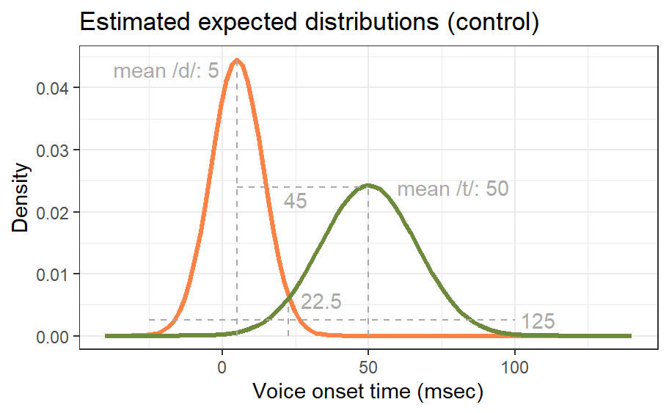

Mean of /d/ distribution: 5

Mean of /t/ distribution: 50

SD of /d/: 80

SD of /t/: 270

PSE: 22.5

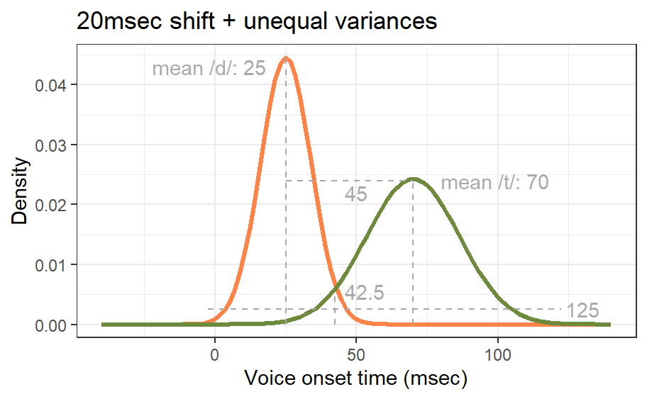

Mean of /d/ distribution: 25

Mean of /t/ distribution: 70

SD of /d/: 80

SD of /t/: 270

PSE: 42.5

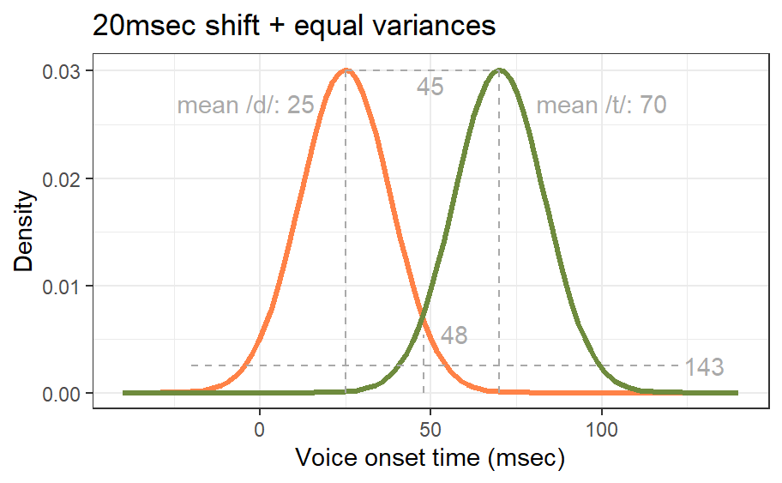

Mean of /d/ distribution: 25

Mean of /t/ distribution: 70

SD of /d/: 175

SD of /t/: 175

PSE: 48

Prosocial vs Neutral Cue

(Presented to label the stimuli that represent the categorical mean)

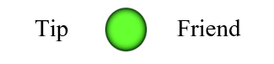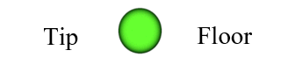

**Prosocial Neutral**